Name: ____________________________
Fruit Tasting Lab Worksheet

Fruit | See | Smell | Taste |    | State
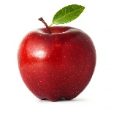  Apple |  |  |  |  | Guess  Actual
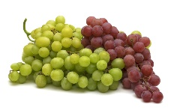  Grape |  |  |  |  | Guess  Actual
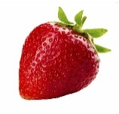  Strawberry |  |  |  |  | Guess  Actual
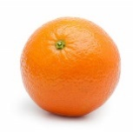  Orange |  |  |  |  | Guess  Actual
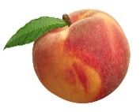  Peach |  |  |  |  | Guess  Actual

